**PF-Lab Assignment**

# **Question 1:**

**While Loop**

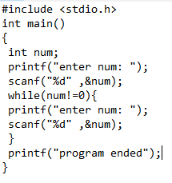

**Output**

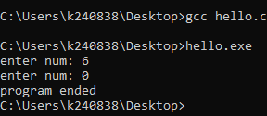

**Do While Loop**

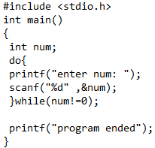

**Output**

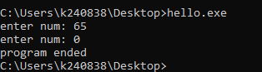

**Explanation:**  The do while loop is more suitable as we only have to take the input once, while in while loop we have to do it twice.

# **Question 2**

Write a program to check whether a given number is a multiple digit number or not.

**CODE**

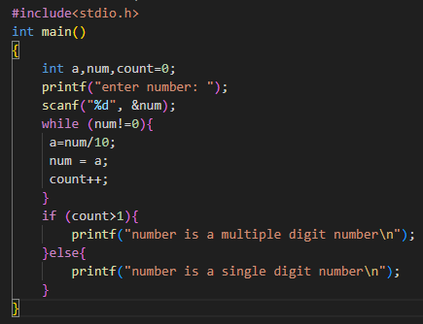

**Output**

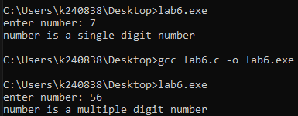

# **Question 3**

Using the above program integrate the number if it is a prime or composite number.

**Code**

**Output**

# **Question 4:**

Write a program to print the following series: 1, 2, 3, 5, 8, 13.

**Code Output**

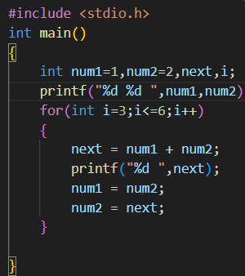

# **Question 5:**

Using for-loop statement print the following series: 65536 32768 10922 2730 546 91 13 1 0

**Code Output**

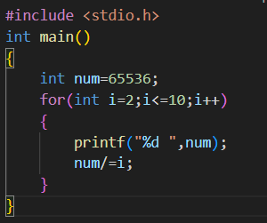

# **Question 6:**

Create a C program to calculate the following series using loop statements.

1 2 2 4 8 32 256 8192 2097152

**Code Output**